I Cloud 7 Assessment

*Data Scientist Jr.*

*Presented by: Jorge Forero*

Executive Summary

Objective:

This report aims to analyze

Key Findings:

* There is a clear correlation between changes in ticket inflow and AHT variability. Weeks with substantial increases in inflow tend to show higher AHT, while weeks with significant inflow reductions generally experience lower AHT.
* Issues such as cancellations, incomplete orders, and app-related problems significantly impact overall handling times and operational efficiency.
* Most issue types exhibit a substantial increase in AHT when tickets are reopened, indicating that unresolved or partially resolved issues require more time and resources upon reopening.
* The negative correlation between AHT and Customer Satisfaction (CSAT) scores indicates that longer handling times are generally associated with lower customer satisfaction. However, some issue types with longer AHTs still maintain higher CSAT scores, suggesting that other factors also influence customer satisfaction.

Recommendations:

* Implement strategies to manage ticket inflow more effectively by increasing self-service options. Enhance chat services with Generative AI to empower customers to find solutions independently.
* Develop targeted training programs for agents or establish a specialized team to handle high-impact issues like cancellations, incomplete orders, and app-related problems. Empower agents to make decisions and take ownership of resolving critical issues to improve first-contact resolution rates.
* Implement advanced diagnostic tools and support frameworks, such as Clinical Decision Support (CDS) tools, to assist agents in resolving issues more efficiently.
* Launch initiatives to improve first-time resolution rates by motivating agents through recognition and rewards for consistently high first-time resolution rates.
* Adopt a holistic approach to improving the overall customer experience by focusing on both reducing AHT and enhancing the quality of service and issue resolution effectiveness.

1. Introduction

This report aims to analyze key metrics and factors impacting the Average Handling Time (AHT) the operations of the contact center at Rappi. By examining the relationship between ticket inflow, issue resolution times, and customer satisfaction, we aim to identify areas for improvement and provide actionable insights to enhance overall efficiency and customer experience.

* 1. Scope of Analysis

This analysis covers a five-week period from April 29, 2024, to May 27, 2024. We focus on examining:

* The impact of ticket inflow and issue type management on overall AHT.
* The key issue types driving changes in AHT.
* The effect of ticket reopens on AHT.
* The correlation between AHT and Customer Satisfaction (CSAT) scores.

1. Methodology
   1. Data Collection and Processing

Data for this analysis was collected from our PostgreSQL database, which includes the following key fields:

CREATED_AT: Timestamp of ticket creation.

TICKET_ID: Unique identifier for each ticket.

COUNTRY: Country where the issue was reported.

GLOBAL_TIPIFICATION: Categorization of the issue.

AHT_SECONDS: Average Handling Time in seconds.

RESOLUTION_TIME: Time taken to resolve the ticket.

IS_REOPEN_AGENT: Indicates if the ticket was reopened by the agent.

CSAT: Customer Satisfaction score.

FRT_QUEUE: Related to queue times.

IS_CANCELLED: Indicates if the ticket was cancelled.

IS_CSAT: Indicates if the ticket had a CSAT survey.

IS_REOPEN_TOTAL: Total reopen status.

IS_SNOOZED_AGENT: Indicates if the ticket was snoozed by the agent.

SURVEY_STATUS: Status of the CSAT survey.

SLA: Service Level Agreement compliance status.

1. Key Findings
   1. Factors Affecting AHT

“What is affecting the AHT overall, the change in Inflow or the increase in issue type management time specifically?”

In this section, we examine the factors impacting overall AHT, focusing on changes in ticket inflow and the average issue type management time. Ticket inflow is measured over one week and five weeks. The Week-over-Week (WoW) changes for each issue type will be also discussed in the next section.

Analysis and Findings

* Week 2024-05-06: Even with an increase of 23,119 tickets, the AHT slightly decreased by 0.31 minutes. The relatively small increase in average issue inflow (148.47) and a moderate change in average issue AHT (2.02) suggest that other factors might have helped improve handling times.
* Week 2024-05-13: A decrease of 8,626 tickets led to an AHT increase of 1.18 minutes. The drop in average issue inflow (-55.66) combined with a rise in average issue AHT (3.38) suggests that even with fewer tickets, certain issues required more time to resolve.
* Week 2024-05-20: Another reduction of 5,436 tickets resulted in a slight AHT increase of 0.34 minutes. The small decrease in average issue inflow (-38.55) and a minor change in average issue AHT (0.71) indicate minimal impact on overall AHT.
* Week 2024-05-27: A significant drop of 18,750 tickets was associated with a 0.50-minute decrease in AHT. The substantial reduction in average issue inflow (-128.29) and a moderate change in average issue AHT (2.87) imply that the lower ticket volume helped reduce the overall AHT.

Visualizations and Data

* Table 1: SQL Query Table Inflow and AHT Changes

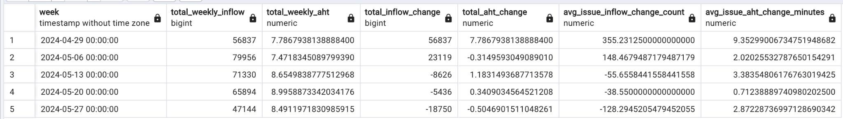

* Table 2: SQL Query Table Issue Type Weekly

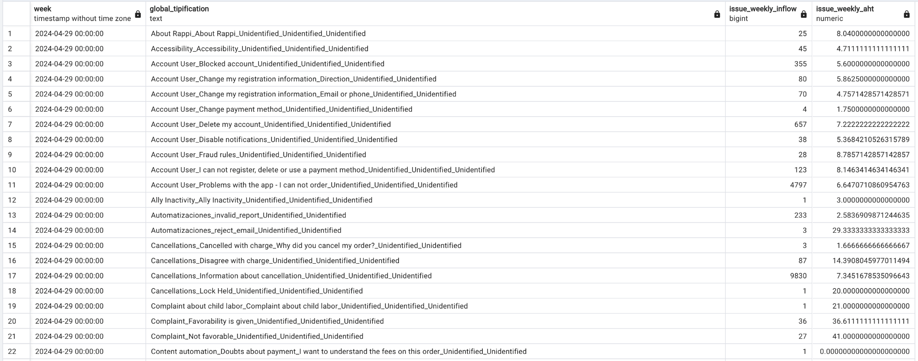

Insights

* There is a clear correlation between changes in ticket inflow and AHT variability. Weeks with substantial inflow increases often show higher AHT, while weeks with significant inflow reductions usually experience lower AHT.
* While inflow changes directly impact AHT, the average issue type management time is also crucial. Weeks with decreased inflow but increased average issue AHT suggest that certain issue types needing longer handling times can negate the benefits of fewer tickets.
* Both ticket volume and the efficiency of handling specific issue types are key in managing overall AHT. Simply reducing AHT without considering resolution efficiency won't yield optimal results.

Overall Insights

* To effectively manage and reduce overall AHT, a comprehensive approach is needed that addresses both ticket volume and issue resolution efficiency. Finding the right balance between these factors is essential for managing AHT.
* Regularly monitoring inflow changes and issue type management times can help identify trends and areas for improvement. Additionally, new data on the financial costs of ticket resolution and issue type resolution can provide insights into what affects the business the most.
  1. Key Issue Types Driving AHT Change

“What are the 3 main issue types that are driving WoW's change in AHT considering inflow and AHT?”

In this section, we analyze the issue types based on total inflow and total AHT, focusing on those with the most significant total AHT and inflow to avoid misleading conclusions from outliers with low inflow counts.

The following key issue types have the most significant impact on the WoW changes in AHT and inflow:

1. Cancellations_Information about cancellation
2. Problems with the order_Incomplete order
3. Account User_Problems with the app

Analysis and Findings:

1. Cancellations_Information about cancellation

* This issue type consistently has the highest AHT, with significant variability. Over a span of four weeks, the AHT ranged from 29.32% to a decrease of 30.52%. This variability corresponds with changes in ticket inflow, which fluctuated by decreasing 3727 tickets and increasing by 2442 tickets from week to week.

1. Problems with the order_Incomplete order

* This is the second most significant issue type due to its notable impact on AHT despite lower inflow variability. Ticket inflow went from 6976 to 9229, with a normal behaviour of the AHT where it showed a positive change with variability of 26.35%. In the second week, it had the highest decrease compared to other issue types, with a 28.20% reduction in inflow, resulting in a 33.53% decrease in AHT.

1. Account User_Problems with the app - I can not order

* This issue type was selected as a top concern due to its high variability. In week five, there was a 35.61% decrease in inflow, leading to a 44.11% reduction in AHT. Other weeks showed inflow variability ranging from 25.56%, with a 7.38% decrease in AHT observed in the fourth week of the analysis.

Visualizations and Data:

* Table 3: SQL Query Table Issue Types

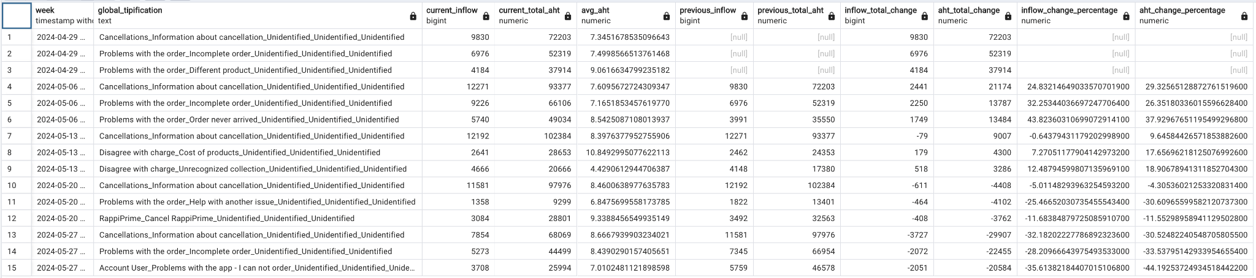

Insights

* The issue type “Cancellations_Information about cancellation” is a significant factor in our operations. The variability observed over four weeks indicates that this issue type greatly impacts overall handling times and operational efficiency.
* For the issue type "Problems with the order_Incomplete order," we see a trend where the average handling time drops to 7.49 minutes per ticket when inflow is high. Conversely, when the inflow of these issues is lower, the average handling time rises to 8.43 minutes per ticket. This suggests that the handling time for this issue type is inversely related to ticket volume.
* The issue type "Account User_Problems with the app - I cannot order" shows significant variability. In week five, there was a sharp decrease of 35.61% in ticket inflow, which led to a substantial 44.11% reduction in AHT. This data suggests that resolving app-related problems can significantly reduce both ticket inflow and AHT.

Overall Insights

* The analysis clearly shows that changes in ticket inflow directly impact AHT, with high inflows leading to increased AHT due to the higher volume of cases that need to be handled.
* We must pay attention to issues where, despite a decrease in the number of tickets, the complexity of the issues demands more handling time. This indicates the need for focused strategies to streamline the resolution process for these types of issues.
* By focusing on high-impact issues like cancellations, incomplete orders and app related problems, there’s potential to significantly reduce overall AHT and improve operational efficiency.
  1. Impact of Reopens on AHT

“Could the Reopen be increasing AHT, what is the actual effect per issue type?”

Here we assess the impact of ticket reopens on the AHT for different issue types, we did this by making a direct comparison of the average AHT for reopened tickets against non-reopened tickets.

Analysis and Findings:

Out of the 146 identified issue types, 132 exhibit a significant increase in overall AHT when tickets are reopened. For instance:

* Order Live_Order settings Payment method modification: This issue type shows the most dramatic increase in AHT when reopened, with an increase of over 1100%.
* Subscription and benefits_Leal_They discounted the Leal coins but did not charge for the Rappicréditos: This issue has a 984% increase in AHT when reopened.
* Complaint about child labor_Complaint about child labor: This issue sees a 950% increase in AHT upon reopening.
* Subscription and benefits_Davipuntos_Higher discount value than requested: Reopened tickets for this issue see a significant increase of 909%

Conversely, some issue types show a reduction in AHT when reopened:

* Automatizaciones_reject_email: With an average AHT of 13.7 minutes, reopened tickets take 92.74% less time to resolve.
* Subscription and benefits_SOAT_What happens if I find an error in my vehicle information when I purchase the policy?: This issue has an average AHT of 42 minutes, with reopened tickets taking 76,19% less time.
* Right of petition_Favorability is given: This issue has an average AHT of 61 minutes, with reopened tickets taking 59.83% less time.
* Order Live_Problems with the order Product in poor condition: This issue has an average AHT of 15 minutes, with reopened tickets taking 53.33% less time.
* Order Live_Order settings Modifying addresses: This issue has an average AHT of 12.37 minutes, with reopened tickets taking 47.47% less time.

High-frequency issue types such as:

Cancellations_Information about cancellation

Problems with the order_Order never arrived

Account User_Problems with the app - I cannot order

Problems with the order_Incomplete order

Problems with the order_Different product

Problems with the order_Product in poor condition

These issue types, with the highest count of reopened tickets, have an average increase of over 120.9% in AHT for reopened tickets.

Visualizations and Data:

* Table 4: Highest AHT Percentage Increase

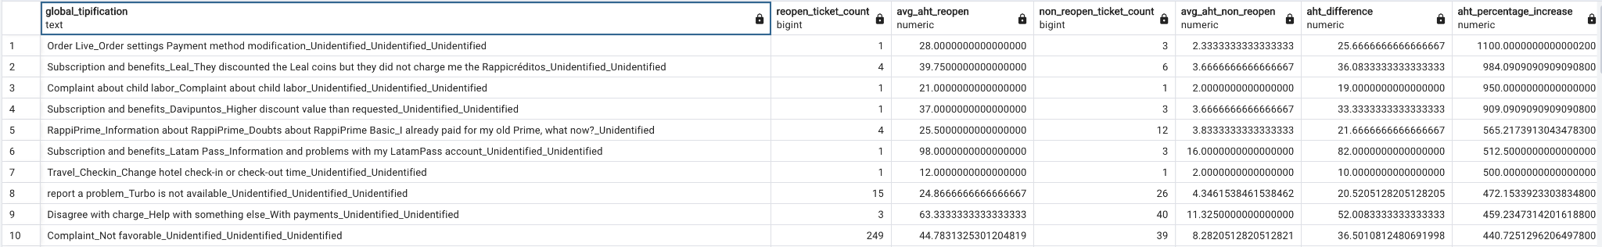

* Table 5: Highest Reopen Ticket Count Issue Types

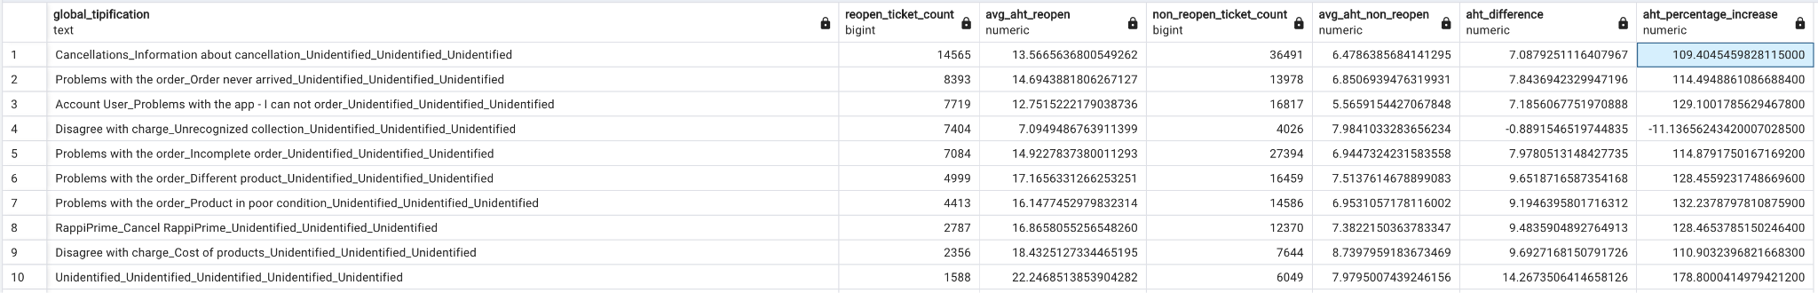

* Table 6: Lowest AHT Percentage Increase

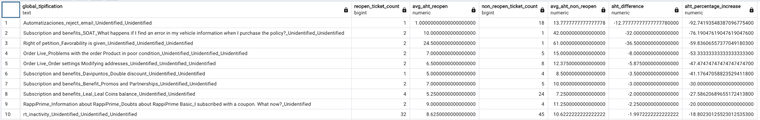

Insights

* The majority of issue types exhibit a substantial increase in AHT when tickets are reopened, indicating that unresolved or partially resolved issues require more time and resources to handle upon reopening.
* A few issue types show a decrease in AHT upon reopening, suggesting that these issues might be more straightforward to resolve on subsequent attempts, or agents are better prepared to handle them.
* High-frequency issue types, particularly those related to cancellations and order problems, significantly increase AHT when reopened. This highlights the need for effective first-time resolutions for these issues to enhance operational efficiency.

Overall Insights

* The data underscores the importance of improving first-time resolution rates, especially for high-impact issues like cancellations and order problems, to reduce the operational burden of reopened tickets.
* Providing agents with targeted training and resources to effectively resolve complex and frequently reopened issues can help reduce AHT and improve customer satisfaction.
* Implementing better support systems and diagnostic tools can aid in resolving issues more efficiently, particularly for those prone to reopening, thereby improving overall team performance.
  1. Correlation Between AHT and CSAT

“Do we see any effect between AHT and CSAT (if AHT varies does it increase or decrease CSAT)?”

In this section, we explore the relationship between Average Handling Time (AHT) and Customer Satisfaction (CSAT) scores. The analysis includes a scatter plot of the correlation and the calculated Pearson correlation coefficient and p-value.

Analysis and Findings:

We conducted a Pearson correlation analysis to determine the relationship between AHT and CSAT scores, this by also removing the tickets that had appropriate CSAT scores with IS_CSAT = “TRUE” and the SURVEY_STATUS = “rated". The results are as follows:

* Pearson Correlation Coefficient: -0.2654
* P-value: 0.0055

The scatter plot chart in Table 7 shows us the correlation between the AHT and CSAT scores across different issue types. Each point represents an issue type, plotting its average AHT against its CSAT score.

Some of the most significant findings are:

* The Pearson correlation coefficient of -0.2654 indicates a negative correlation between AHT and CSAT scores, this suggests that generally as AHT increases, CSAT scores tend to decrease.
* The p-value of 0.0055 indicates that the correlation is statistically significant, meaning there is strong evidence to suggest that AHT and the CSAT are related in the population from which the data was sampled.
* When analyzing tickets with an AHT of below 10 minutes, the average CSAT score is 3.03 out of 5, the highest average observed. This finding corroborates the results seen in the chart and the correlation analysis, highlighting the positive impact of shorter handling times on customer satisfaction.

Visualizations and Data:

* Table 7: Correlation Scatter Plot

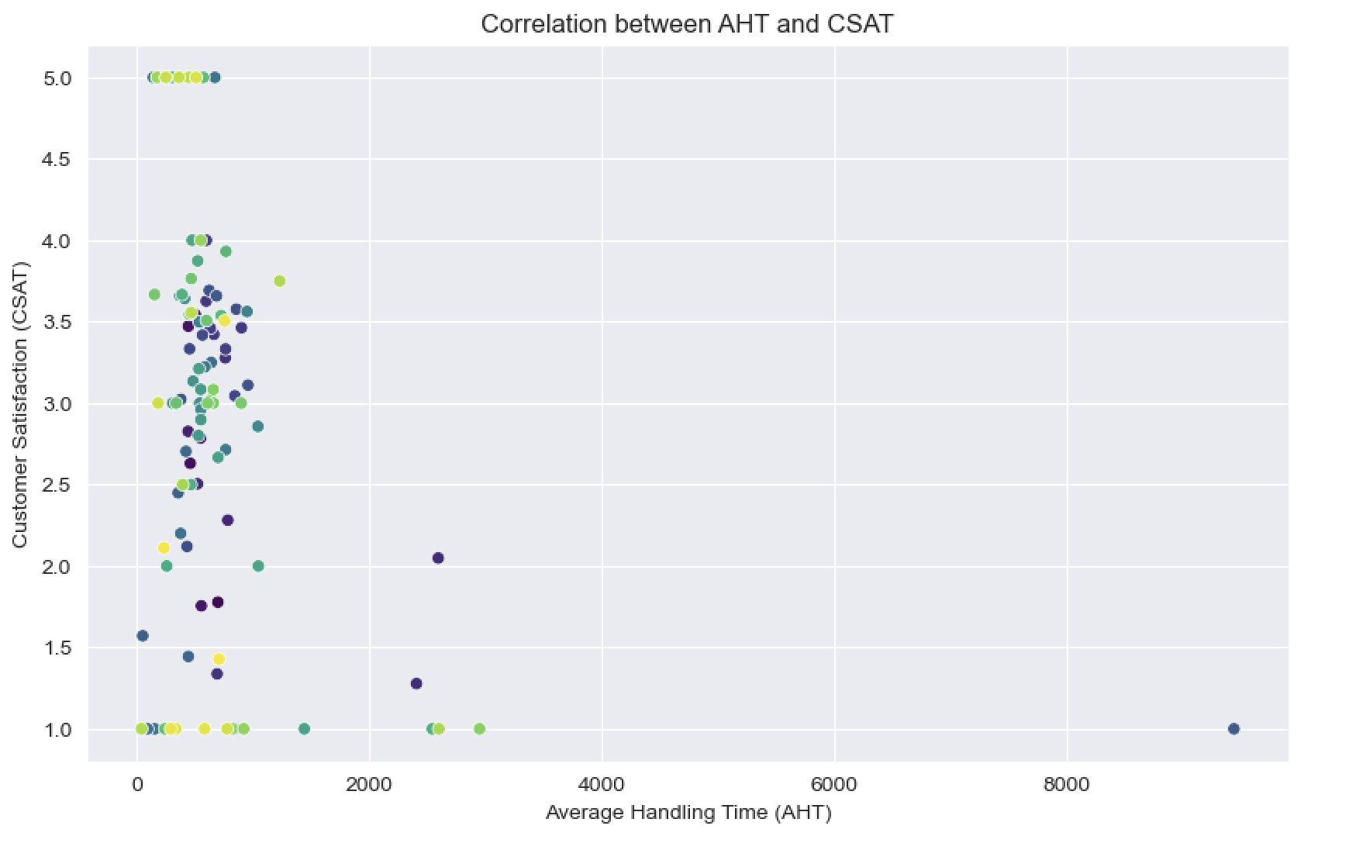

Insights

* The negative correlation between AHT and CSAT indicates that longer handling times are generally associated with lower customer satisfaction. This finding is crucial for understanding how operational efficiency impacts customer perceptions and satisfaction
* The scatter plot shows variability in the relationship between AHT and CSAT across different issue types. Some issue types with longer AHTs still maintain higher CSAT scores, suggesting that factors other than AHT may also play a role in customer satisfaction.

Overall Insights

* While reducing AHT is important, it is also essential to consider other factors that influence CSAT. A holistic approach to improving the overall customer experience, including quality of service and issue resolution effectiveness, is necessary.
* Regular monitoring of the correlation between AHT and CSAT can help identify trends and areas for improvement. By continuously analyzing this relationship, the contact channels can implement timely interventions to maintain high customer satisfaction.

1. Recommendations
   1. Improvement Areas

* Implement strategies to manage ticket inflow more effectively while optimizing the efficiency of handling specific issue types. Based on the data, we recommend increasing self-service options. Using FAQs, knowledge bases, or interactive guides is typically suitable, but enhancing chat services with Generative AI can empower customers to find solutions independently.
* Prioritize resolving high-impact issues such as cancellations, incomplete orders, and app-related problems to reduce overall AHT and improve operational efficiency. Providing targeted training for agents or establishing a specialized team for these issues can equip agents with the skills and knowledge to handle them efficiently. Empowering agents to make decisions and take ownership of resolving critical issues can improve first-contact resolution rates.
* Implement enhanced diagnostic tools and support frameworks to aid agents in resolving issues more efficiently. For example, Clinical Decision Support (CDS) tools can assist in information gathering, facilitate cognitive processes by organizing data, and help generate differential diagnoses for each issue type.
  1. Strategic Initiatives
* Utilize new data related to the financial costs of ticket resolution and sentiment analysis to understand their impact on the business and to help find the optimal AHT value.
* Implement initiatives to improve first-time resolution rates, especially for issues that frequently require reopening. Start by motivating agents through recognition and rewards for consistently high first-time resolution rates. This can be done through incentives, awards, or bonuses.
* Design and implement training programs that focus on equipping agents with the skills needed to handle complex and high-frequency issues effectively. Begin with problem-solving and critical thinking training to help agents analyze issues, identify root causes and risks, and determine the best course of action.

1. Next Steps

* Action Items:

Immediate: Initiate the implementation of self-service options and enhance chat services with generative AI. Develop targeted training programs for agents

Within 3 Months: Implement enhanced diagnostic tools and support frameworks. Launch recognition and rewards initiatives for high first-time resolution rates.

* Future Analysis

Suggest areas for future analysis or additional data collection to have advanced analytics over the AHT and the CSAT. With more advanced techniques it is expected to find optimization options with new trends and factors impacting the customer satisfaction and operational efficiency.